**Experiment No :** 08

**Experiment name :** Write a C Prgram to print Fibonacci Series .

**Methodology :**

1. Initialize the first two terms of the series, usually 0 and 1.
2. Prompt the user to enter the number of terms they want in the Fibonacci series.
3. Use a loop to generate the next term in the series and print each term.
4. DRepeat the loop until the desired number of terms are generated.

**Flow-Chart :**

**Code :**

while(count<num

Output: fibo

Else

fibo = first + second ;

first = second ;

second = fibo

Output: fibo

fibo = count ;

if(count<=1)

Input number

scanf("%d",&num);

Diclear and initilize int first = 0 , second = 1 ,count=0, num , fibo ;

#include<stdio.h>

int main()

{

int first = 0 , second = 1 ,count=0, num , fibo ;

printf("Enter renger of Fibonacci series : ");

scanf("%d",&num);

while(count<num){

if(count<=1){

fibo = count ;

}

else{

fibo = first + second ;

first = second ;

second = fibo;

}

printf("%d ",fibo);

count++ ;

}

return 0;

}

**Output:**

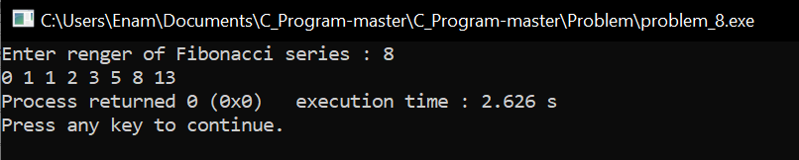

**Result discussion :**

Fibonacci series, this is a series where I have taken input from the user, let's say 10, what is the sum of these 10 ten numbers? We can find that through this Fibonacci series, and 1+1 +2+3 will be the sum of the 10th number.